PDC Lab 1
Advait Deochakke
20BCE1143 – 27 July ‘22

Question 1: Print your name two times using OpenMP
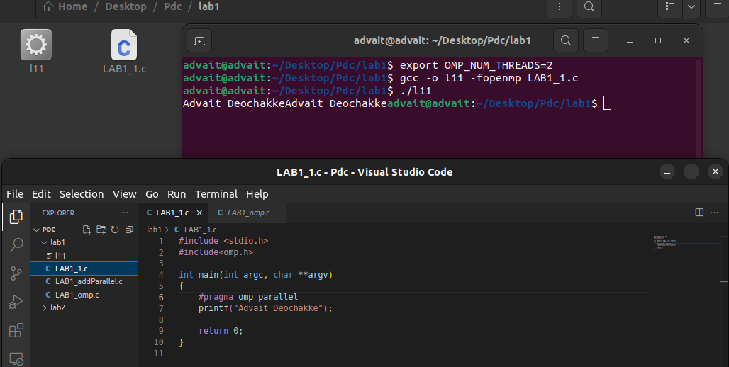

Question 2: Print your name four times using OpenMP
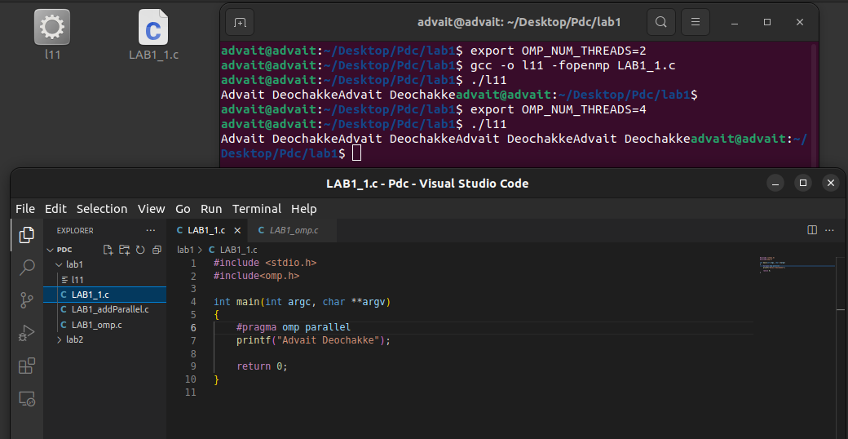

#include <stdio.h>
#include<omp.h>

int main(int argc, char **argv)
{
#pragma omp parallel
printf("Advait Deochakke");

return 0;
}

Question 3: Perform array addition using parallel construct and print the results
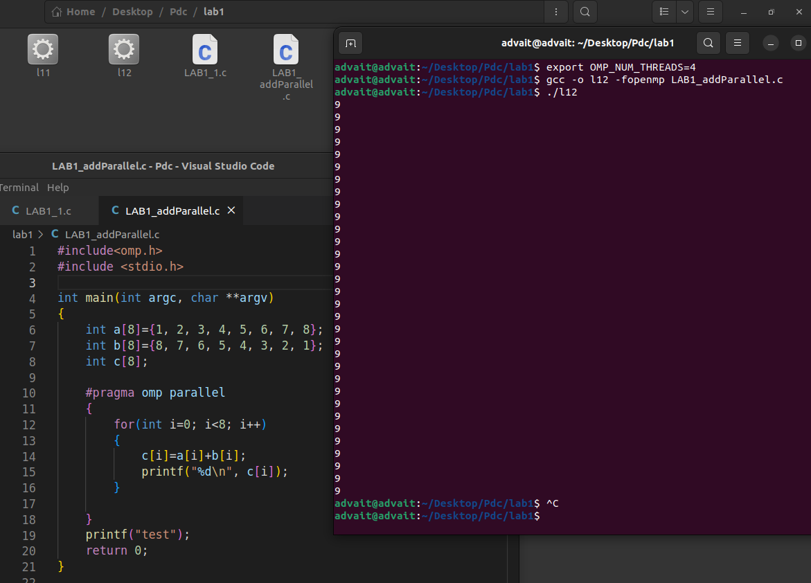

Output : Printed 9 times for each iteration on each CPU core, total 36 times addition is done and result of the addition is printed.

#include<omp.h>
#include <stdio.h>

int main(int argc, char **argv)
{
int a[8]={1, 2, 3, 4, 5, 6, 7, 8};
int b[8]={8, 7, 6, 5, 4, 3, 2, 1};
int c[8];

#pragma omp parallel
{
for(int i=0; i<8; i++)
{
c[i]=a[i]+b[i];
printf("%d\n", c[i]);
}

}
printf("test");
return 0;
}

